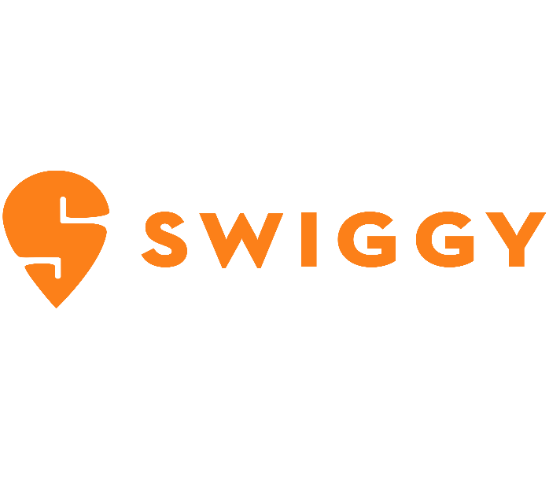

**Product Dissection for Swiggy Food Delivery App**

**Company Overview:**

Swiggy, founded in 2014 in Bangalore, India by Sriharsha Majety, Nandan Reddy, and Rahul Jaimini, has emerged as a leading food delivery service in India. Known for its quick delivery, wide range of restaurant options, and user-friendly interface, Swiggy has significantly transformed the landscape of food ordering and delivery in India.

**Product Dissection and Real-World Problems Solved by Swiggy**:

**Convenience in Food Ordering**: Swiggy addresses the need for convenient and quick access to a variety of cuisines from local and popular restaurants.

**Efficient Delivery System**: It solves the problem of time-consuming and often inconvenient process of going out to eat or pick up food, especially in busy urban areas.

**Diverse Food Options**: Swiggy provides access to a wide range of food options, catering to different tastes and dietary preferences

**Case Study: Real-World Problems and Swiggy’s Innovative Solutions:**

**Problem 1: Time Constraints and Limited Access to Food**

**Real-World Challenge:** In today’s fast-paced world, people often lack the time or resources to cook regular meals. Access to healthy and diverse food options can also be limited, especially in areas with limited restaurants or grocery stores.

**Swiggy’s Solution:** Swiggy provides a convenient and readily available solution by partnering with a vast network of restaurants and food vendors. Users can browse menus, place orders, and track their deliveries in real-time, all within a user-friendly app. This addresses the time constraint issue and grants access to a wide variety of culinary options, even in areas with limited physical options.

**Problem 2: Food Delivery and Decision Fatigue**

**Real-World Challenge:** With countless restaurants and cuisines available, choosing what to eat can be overwhelming. Scrolling through endless menus and reading reviews can be time-consuming and lead to decision fatigue.

**Swiggy’s Solution**: Swiggy tackles this challenge through personalized recommendations and curated content. The app uses user data and location to suggest restaurants and dishes based on preferences and dietary needs. Additionally, Swiggy offers curated lists and collections highlights popular choices, new trends, and local favorites. This helps users discover new options and make informed decisions quickly.

**Problem 3: Lack of Transparency and Trust in Food Delivery**

**Real-World Challenge:** Concerns around hygiene, food safety, and order accuracy can deter people from using food delivery services. Lack of transparency in the delivery process can also lead to frustration and mistrust.

**Swiggy’s Solution:** Swiggy addresses these concerns through various measures. Restaurants are partnered based on hygiene and food safety certifications. The platform provides live tracking of orders, allowing users to see the delivery progress in real-time. Additionally, Swiggy offers customer support and grievance redressal mechanisms to ensure transparency and built trust.

**Conclusion:**

Swiggy’s success lies in its ability to understand and address real-world problems faced by its users. By focusing on convenience, food discovery, transparency and expanding its services, Swiggy has become an integral part of many Indian households. The platforms continued innovation and commitment to solving user problems are likely to solidify its position as a leading food delivery and convenience service provider in the Indian market.

**Top Features of Swiggy:**

1. **Easy-to-Use Interface:** Users-friendly app design that makes browsing and ordering food simple and efficient.
2. **Wide Range of Restaurants:** Access to a vast selection of restaurants and cuisines.
3. **Real-Time Tracking:** Allows users to track their orders in real-time.
4. **Multiple Payment Options:** Offers various payment methods including cash on delivery, digital wallets and online banking.
5. **Ratings and Reviews:** Users can rate and review restaurants and dishes, aiding in informed decision making for others.

**Impact on the Food Delivery Industry:**

Swiggy’s approach to solving real-world problems in food delivery has not only provided immense convenience to consumers but also impacted the food industry by:

**Enhancing Customer Reach for Restaurants:** By partnering with Swiggy, restaurants have expanded their customers base significantly.

**Creating Employment Opportunities:** The demand for delivery person has grown, providing job opportunities in various regions.

**Promoting Food Culture Diversity:** Swiggy’s platform has made it easier for people to explore and enjoy a variety of cuisines, contributing to the appreciation and spread of diverse food cultures.

**Schema Description:**

The schema for Swiggy involves multiple entities that represent different aspects of the platforms, including Users, Restaurants, Orders, Deliveries and more. Each entity has specific attributes that describe its properties and relationships with other entities.

**User Entity:**

Users are essential to the platform, representing individuals who use the services:

* **User ID (Primary Key):** A unique identifier for each user.
* **Username:** The user’s chosen username.
* **Email:** Email address used for account-related communications.
* **Phone Number:** The user’s contact number.
* **Address:** Stored addresses for delivery purposes.
* **Password:** Encrypted password for account security.

**Restaurant Entity:**

Restaurant are key partners, providing the diverse food options available on the platform.

* **Restaurant ID (Primary Key):** A unique identifier for each restaurant.
* **Name:** Name of the restaurant.
* **Location:** Physical address of the restaurant.
* **Cuisine Type:** Types of cuisine offered.
* **Rating:** Average customer rating of the restaurant.

**Order Entity:**

Orders encapsulate the details of each transaction made by the users:

* **Order ID (Primary Key):** A unique identifier for each order.
* **User ID (Foreign Key Referencing User Entity):** The user who placed the order.
* **Restaurants ID (Foreign Key Referencing Restaurant Entity):** The restaurant from which the order is placed.
* **Total Amount:** Total cost of the order.
* **Order status:** Status of the order (e.g., preparing, en route).
* **Order Date:** The date and time when the order was placed.

**Delivery Entity:**

Deliveries are crucial for transporting orders from restaurants to users:

* **Delivery ID (Primary Key):** A unique identifier for each delivery.
* **Order ID (Foreign Key Referencing Order Entity):** The order being delivered.
* **Delivery Executive ID:** Identifier for the delivery executive.
* **Estimated Delivery Time:** Expected time for the orders to be delivered.
* **Delivery Status:** Current status of the delivery (e.g., picked up, delivered).

**Payment Entity:**Payments record the financial transaction for each order:

* **Payment ID (Primary Key):** A unique identifier for each payment transaction.
* **Order ID (Foreign Key Referencing Orders Entity):** The order for which the payment is made.
* **Amount:** Amount of the transaction.
* **Payment Method:** Method of payments (e.g., card, wallet, COD).
* **Payment Status:** Status of the payment (e.g., successful, pending).

**Item Entity (represents items in an order):**

Items represents the individual menu selections included in an order:

* **Item ID (Primary Key):** A unique identifier for each menu item.
* **Order ID (Foreign Key Referencing Orders Entity):** The order including this item.
* **Name:** Name of the item.
* **Quantity:** Number of items ordered.
* **Price:** Price of the item.

**Relationships:**

* **Users place Orders:** Each user can place multiple orders, and each order is linked to a singular user.
* **Orders contain Items:** Each order can contain multiple items, and each item is part of one order.
* **Restaurants fulfill Orders:** Each order is associated with one restaurant, and a restaurant can have multiple orders.
* **Orders require Delivery:** Each order is linked to a single delivery instance, and each delivery is associated with one order.
* **Orders involve Payments:** Each order is associated with one payment, and each payment corresponds to one order.

**ER Diagram:**

Let’s create an Entity-Relationship (ER) diagram to clearly illustrate the connections and characteristics of the elements in the Swiggy database structure. This ED diagram will act as a visual guide, highlighting the essential parts of Swiggy’s data architecture. Utilizing this diagram will help us understand the complex relationships and interactions that shape the functioning of the platform.

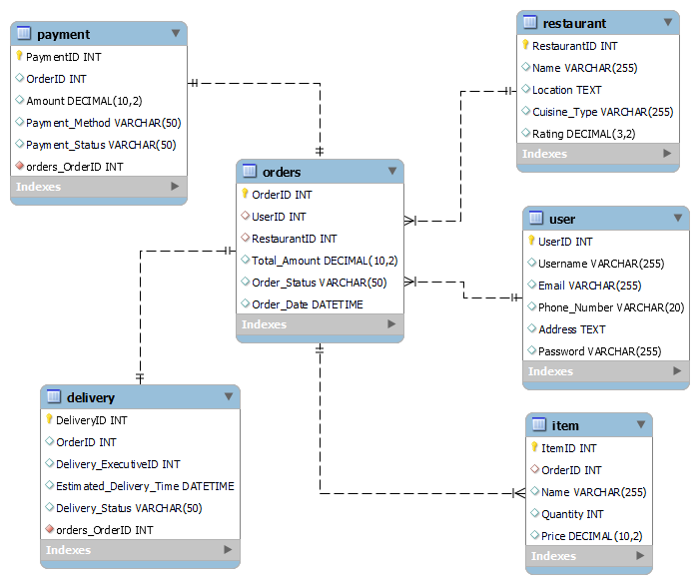

**Conclusion:**

In this study, we have analyzed Swiggy’s operational framework and its impact on the food delivery ecosystem. Swiggy has transformed the landscape of food ordering and delivery by addressing real-word challenges through technological innovation and user-centric solutions. The platform integrates entities such as users, restaurants, orders, deliveries, payment and menu items, creating a robust and efficient system. This comprehensive structure not only facilitates seamless transactions but also caters to a diverse range of consumer needs and preferences. By analyzing Swiggy’s model, we gain valuable insights into how it successfully navigates the complexities of the food delivery sector, enhancing convenience for customers while providing vital support to restaurant partners. Swiggy’s strategic approach and adaptive technology have propelled its growth, cementing its position as a leading player in the ever-evolving domain of online food services.